**Steps followed to create AWS instance and implement load balancer**

1. Created an ec2 windows instance with basic configuration

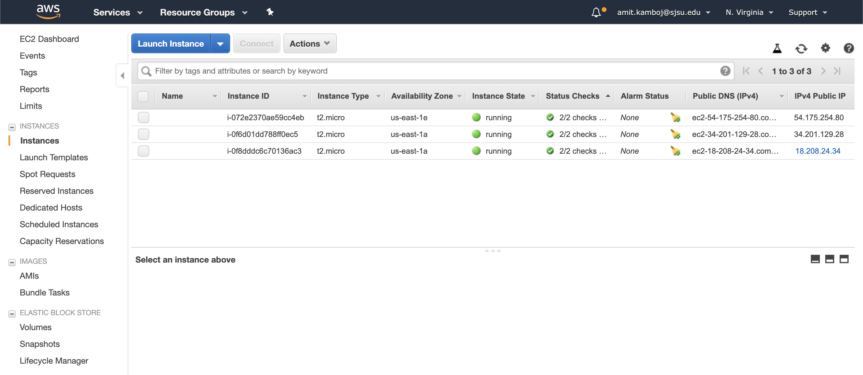

1. Deployed the api code on instance

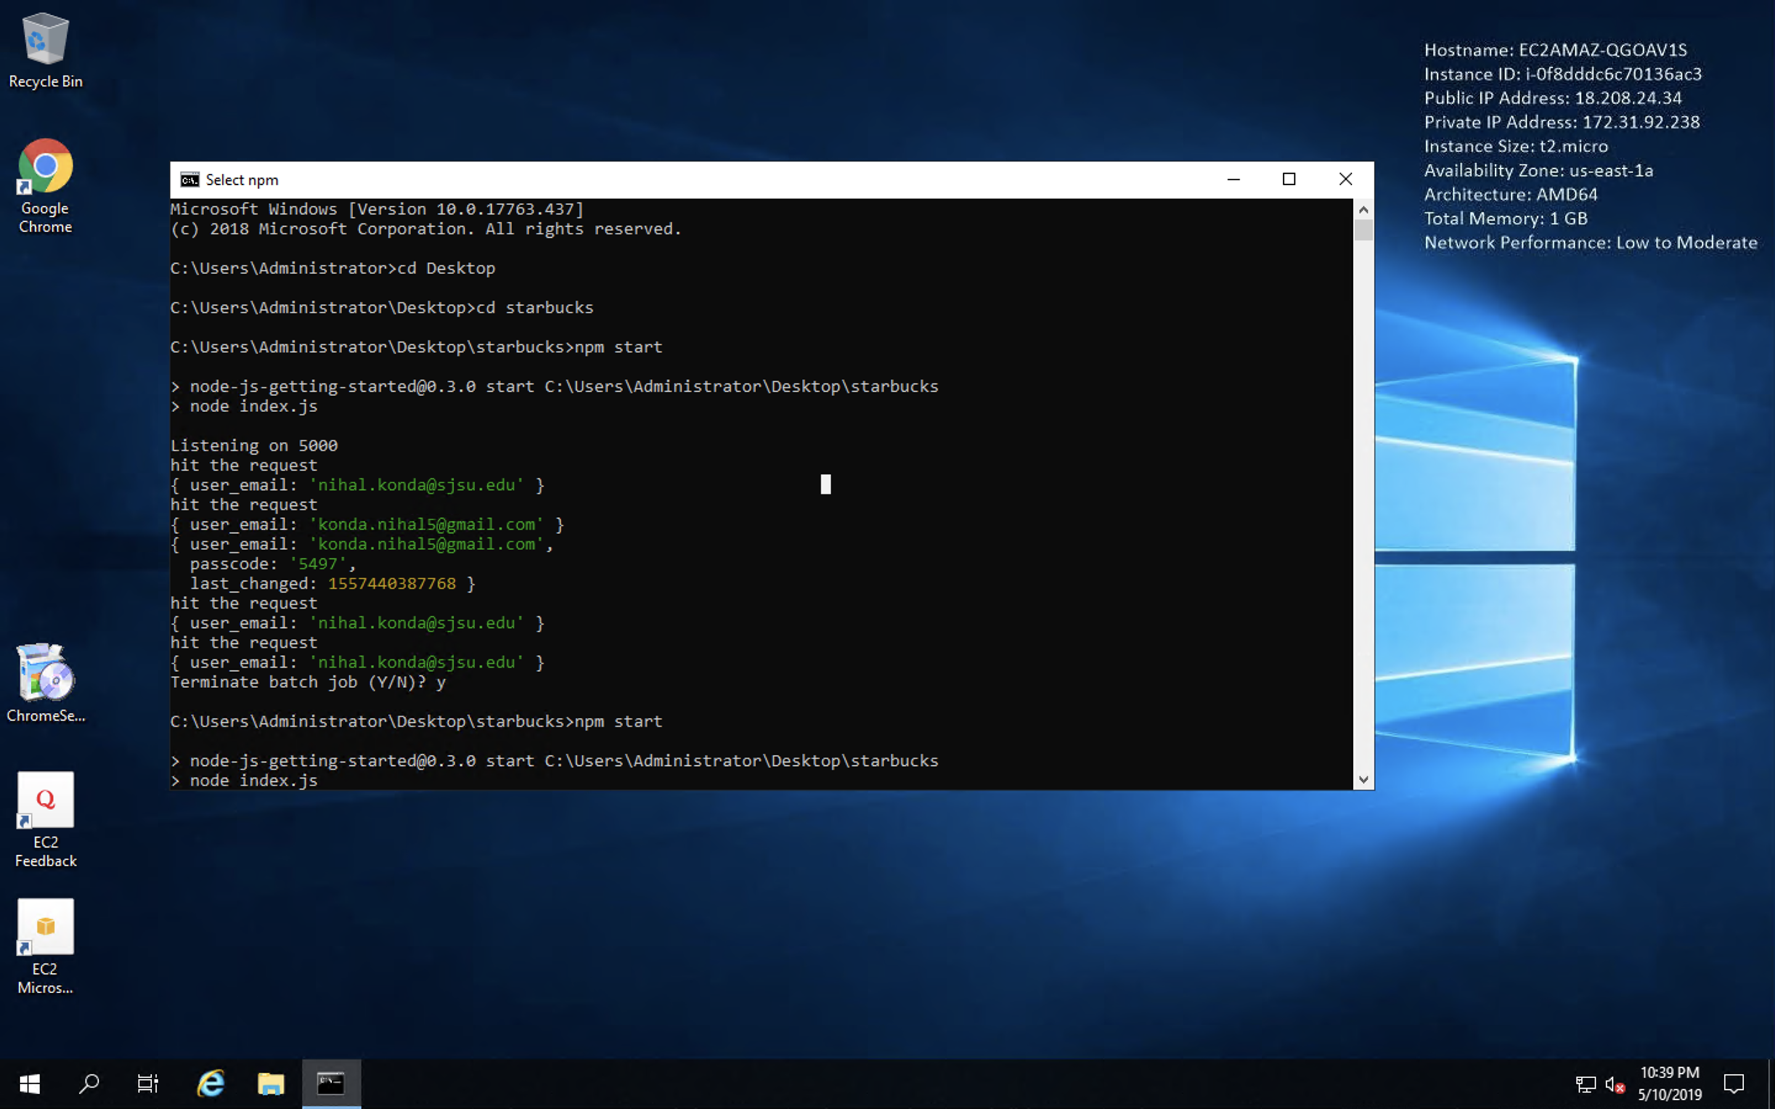

1. Created auto scaling group for the instance

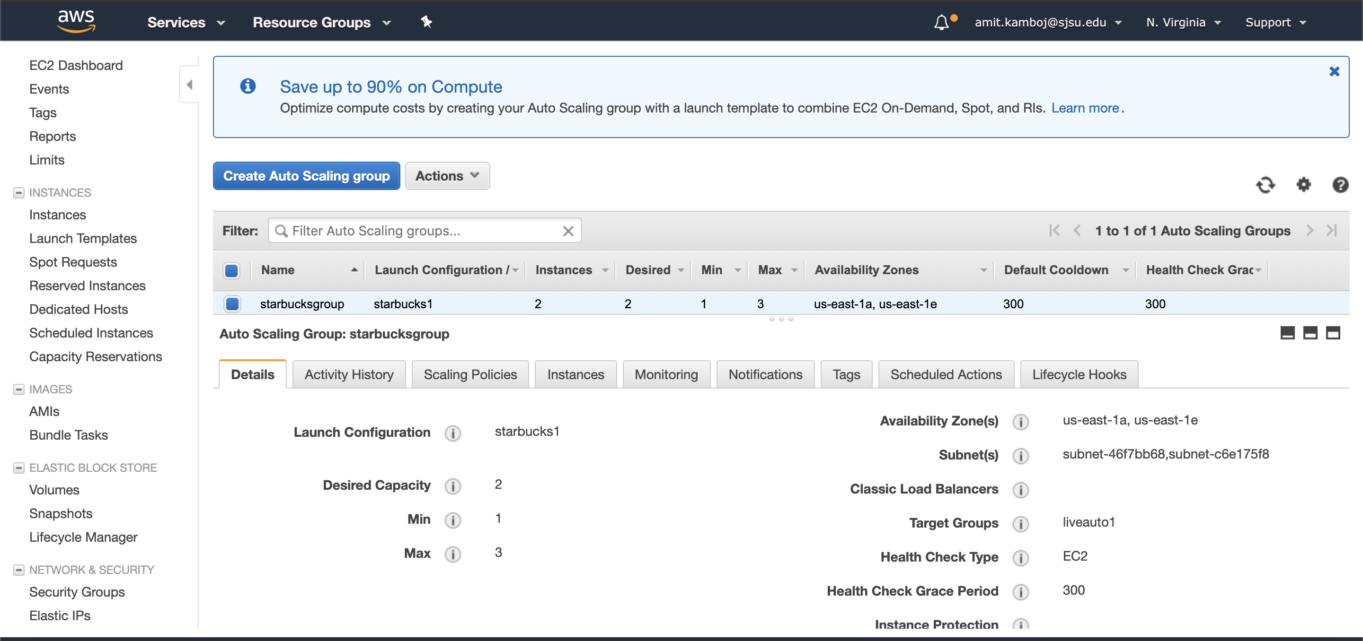

1. Implemented load balancer

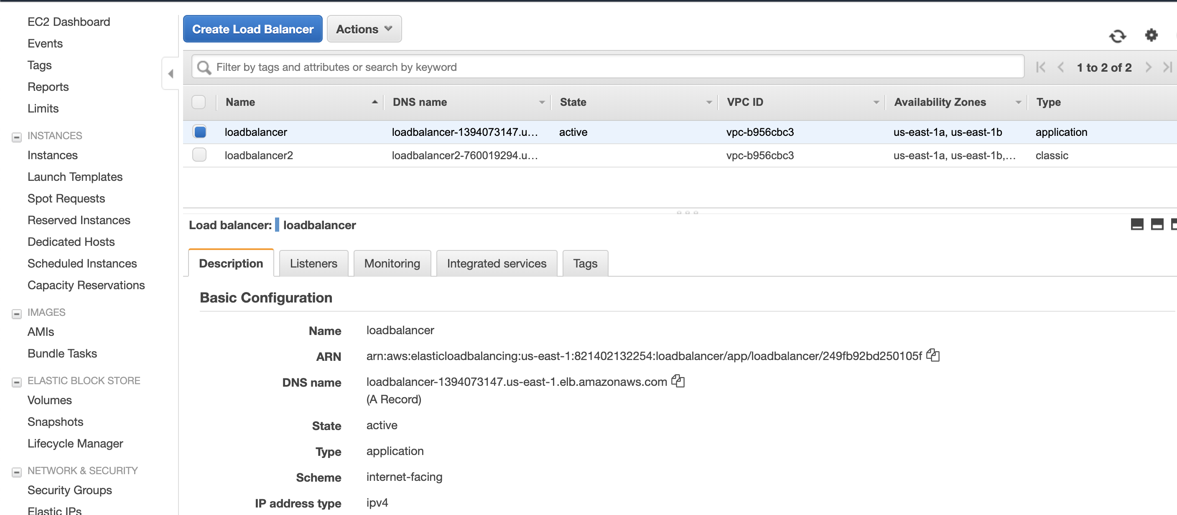

1. Created target group that contains the instances available at a time

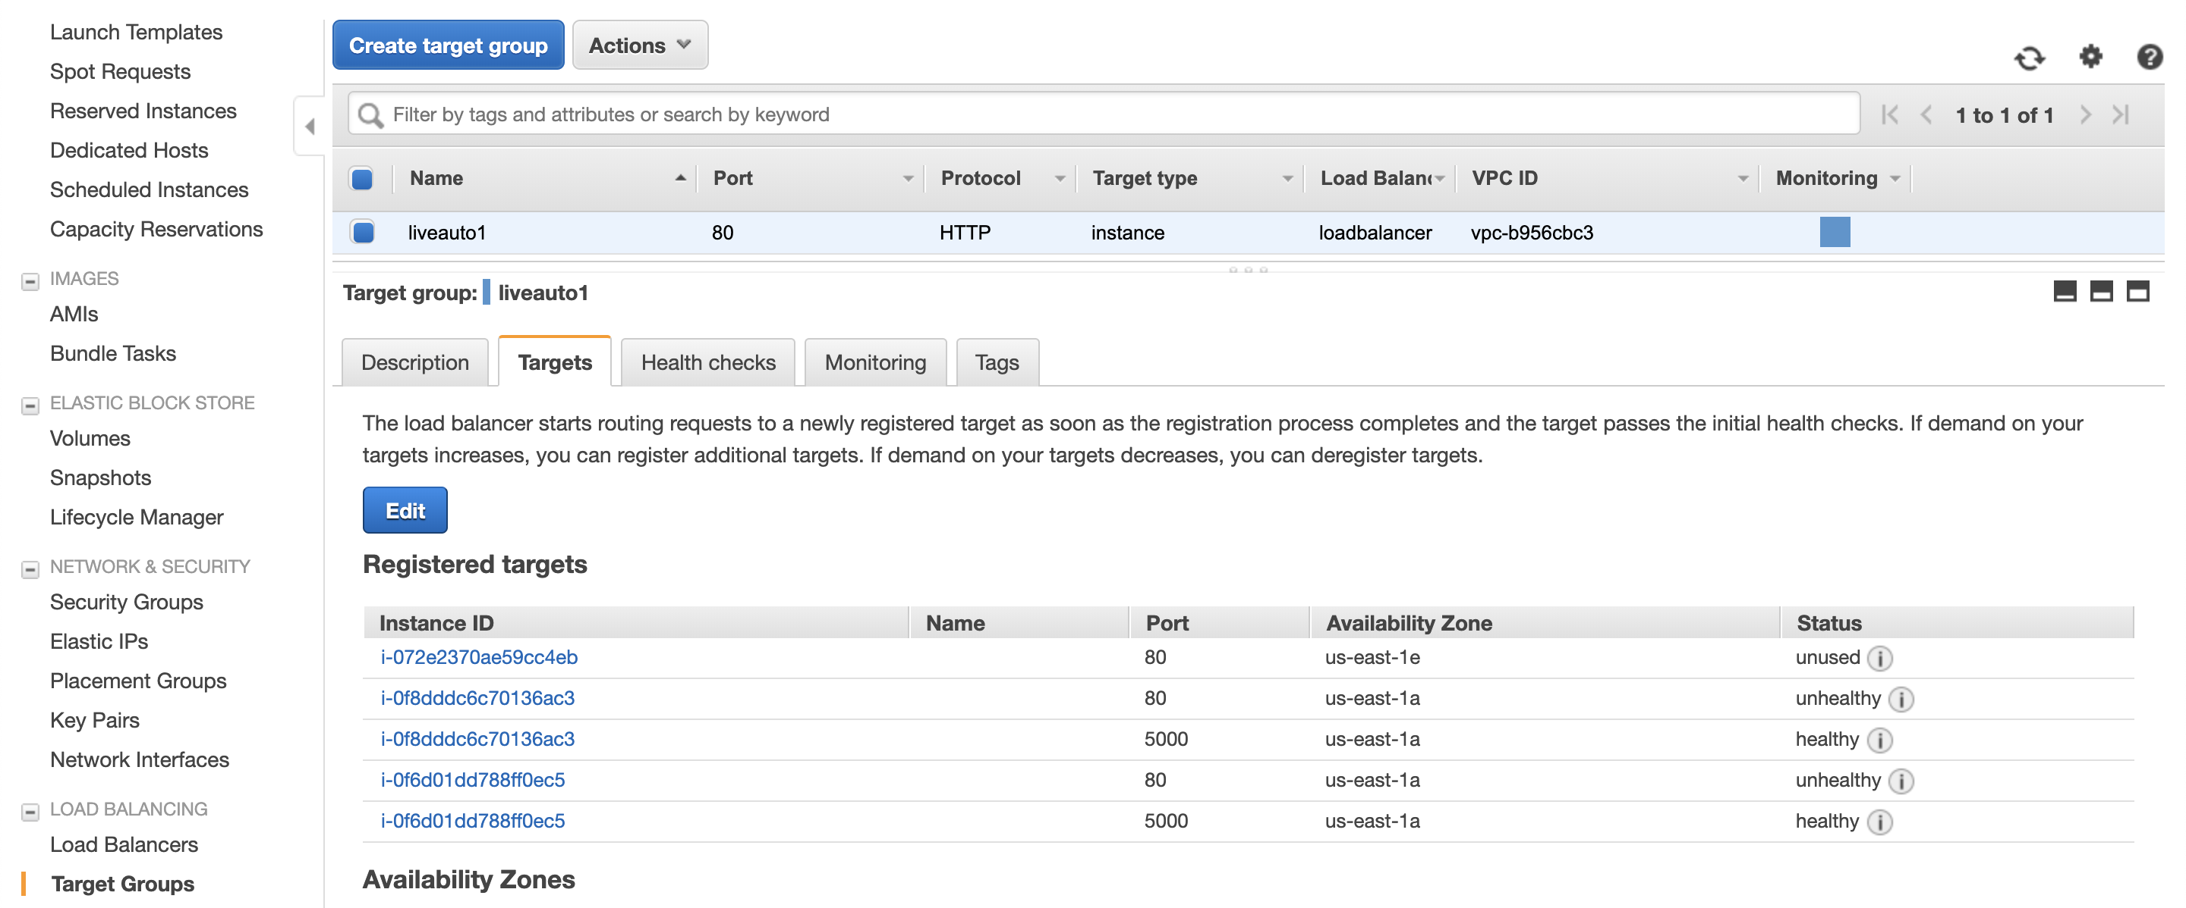

1. Attach target group with Load balancer

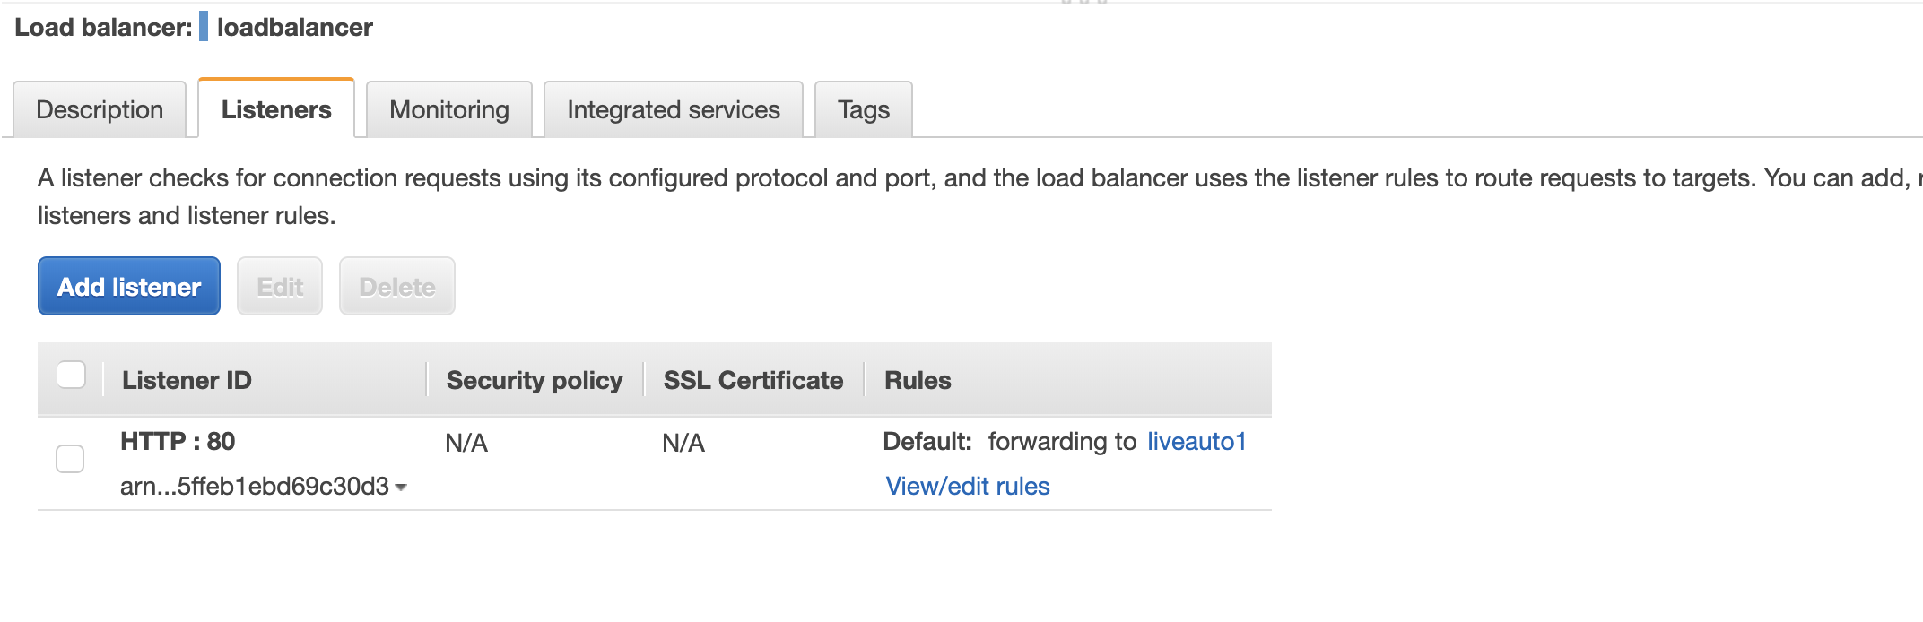

1. Added rule to load balancer to direct the requests

